Daily Stand-Up Meeting
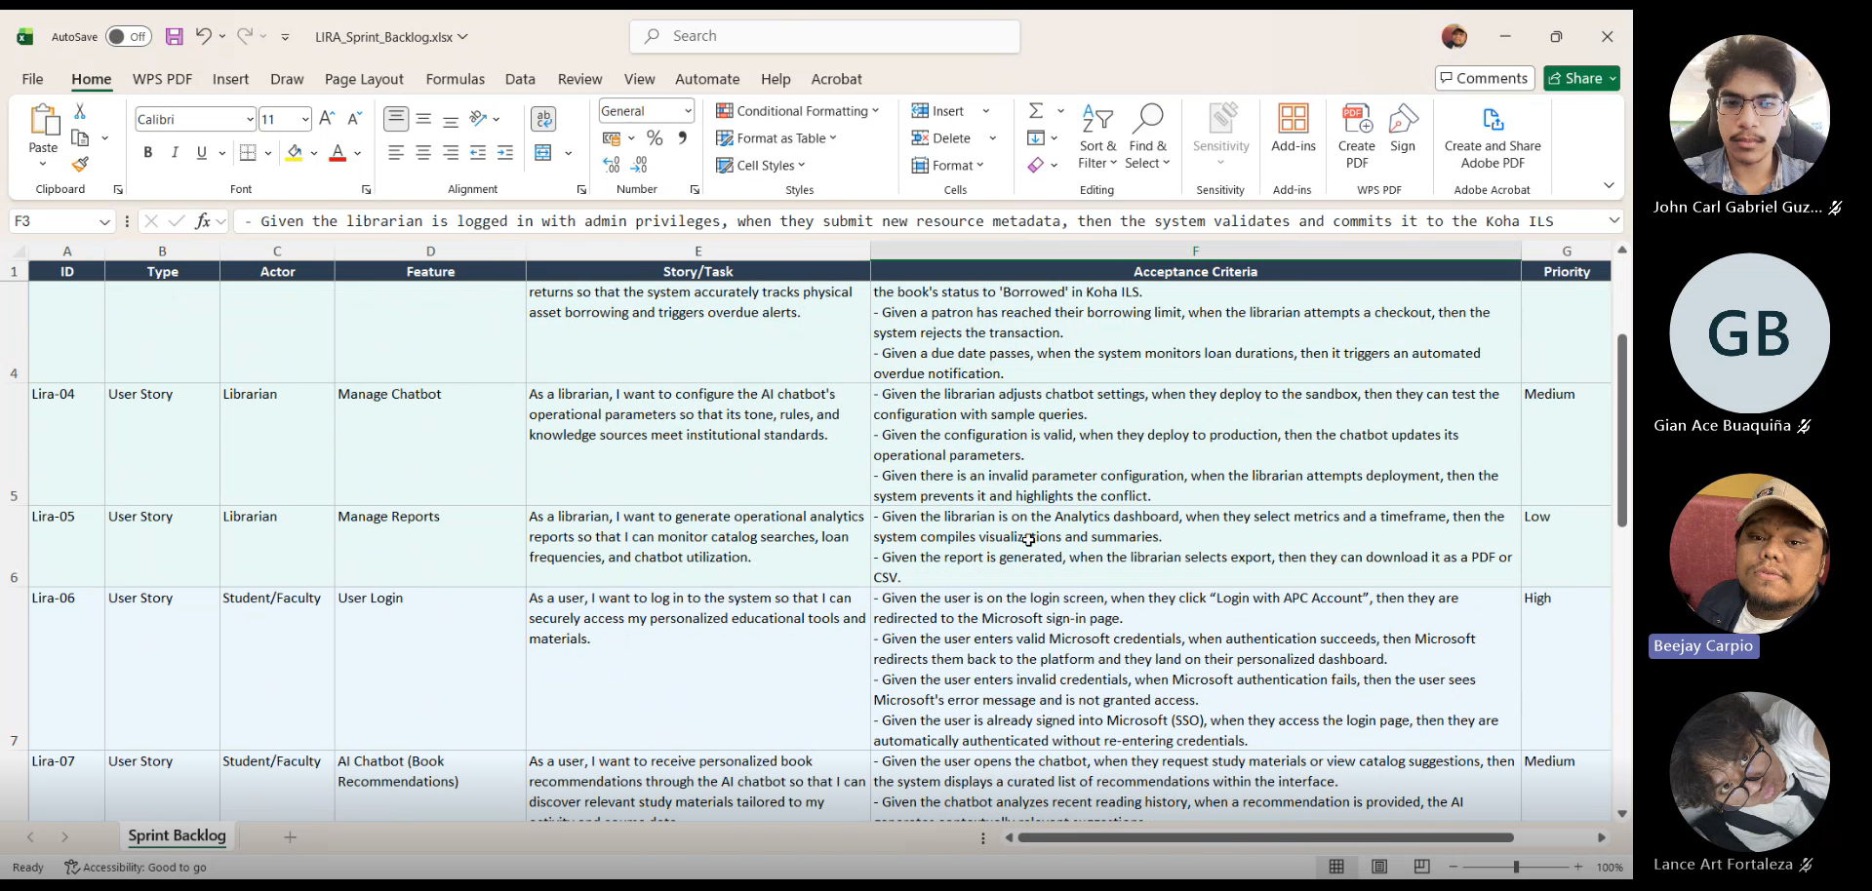
Minutes of meeting
Date: 09/14/2026
Meeting Called By: Cache Flow

Attendees
Gian Ace Buaquiña
Beejay A. Carpio
Lance Art P. Fortaleza
John Carl Gabriel Guzman

Summary
We discussed initiating a 10-day Sprint 1 focusing on developing a working prototype before the October 12 defense. We divided team roles: Lance and Beejay will focus on the student side (View Library Catalog and SSO login), while Gian and JC will handle the librarian/admin side (Manage Library Catalog). We updated the features to include e-book summaries and citations for the chatbot, and added "Borrow Books" to the Use Case diagram for students and faculty. The Team will plan an onsite visit to talk to Sir Jojo regarding the Koha Catalog API access and CMS integration. We clarified that physical books will not be digitized into e-books, as the project will focus solely on the existing Koha catalog data.
What will do for today, the focus is setting up the backlog, tracker, and creating the SharePoint/Teams documentation folders.
What will do for tomorrow, the team will start active UI development and hold a 15-minute stand-up meeting around midday.

